YEAR 12 CHEMISTRY NAME:____________________________

ATOMIC STRUCTURE AND BONDING ASSIGNMENT TEST 1 (30 MARKS)

Part A: Multiple Choice

Choose the best answer and write ALL your answers in the appropriate box below

1 | 2 | 3 | 4 | 5 | 6 | 7 | 8 | 9 | 10

- Element X has an electron configuration of 2,8,2 while element Y has the configuration 2,7. Which of the following statement are true?

    - The two would form a covalent molecule XY₂
    - The two would form an ionic lattice with the formula XY₂
    - The two would form an ionic lattice with the formula X₂Y
    - Y is more electronegative than X
    - X forms metallic bonds
    - Y can form multiple covalent bonds.

- i, iv, & v
- ii, iv, & v
- ii, iv, v, & vi
- iv only

- The electron configuration of an ion with a +2 charge is 2,8,8. What is the electron configuration of the neutral atom?
  - 2,8,6
  - 2,2
  - 2,8,2
  - 2,8,8

- Which one of the following electron configurations represents an element that would most likely form a monoatomic ion with a charge or valency of (–3)?

a. 2,3
b. 2,4
c. 2,5
d. 2,8

- In which one of the following pairs do both chemical species have the same electron configuration?

  - Na⁺ and Ar
  - Na⁺ and F⁻
  - Na⁺ and K⁺
  - Na⁺ and Mg⁺³

- Consider the following statements about the Periodic Table.
    - Elements are arranged in increasing order of atomic mass.
    - Elements with similar chemical properties are in groups.
    - Atomic radii of elements decrease across the periods.
    - First ionisation energies of elements increase down the groups.

Which of the statements above are correct?
- i. and ii.
- ii. and iii.
- iii. and iv.
- i., ii. and iii.

- Consider the ion below.
81 | Tl | 3+
204 | Tl
Which one correctly lists the correct number of Protons, Neutrons and Electrons?
Protons Neutrons Electrons
a. 81 84 121
b. 204 81 201
c. 81 123 78
d. 204 81 201

Refer to the following table to answer Questions 6 and 7.
The table shows the approximate successive molar ionisation energies (in kJ mol–1) of five elements denoted I to V.

Element | Ionisation energy
Element | 1st | 2nd | 3rd | 4th
I | 502 | 4570 | 6919 | 9550
II | 580 | 1820 | 2750 | 11600
III | 590 | 1145 | 4910 | 6490
IV | 744 | 1460 | 7740 | 10550
V | 1250 | 2300 | 3820 | 5160

- Which two elements are most likely to be Group 2 (alkaline earth) metals?
  - I and III
  - III and IV
  - II and V
  - I and V

- Which element would react with chlorine to form a compound with the general formula ACℓ3, where A represents one of the five elements (I to V) listed in the table above?

  - I
  - II
  - III
  - IV

- Which one of the following best explains the decrease in atomic radius as the atomic number increases across Period 3 of the Periodic Table?
  - increasing nuclear charge
  - decreasing number of neutrons
  - decreasing number of protons
  - the elements becoming more noble gas-like

- What is the formula of an ionic compound consisting of positive ions with a configuration 2,8,8 and negative ions with the same configuration?
  - LiF
  - MgS
  - NaF
  - KCℓ

Part B: Short Answer

Write ALL your answers in the space provided

- A plot showing the successive ionisation energies of calcium is given below.

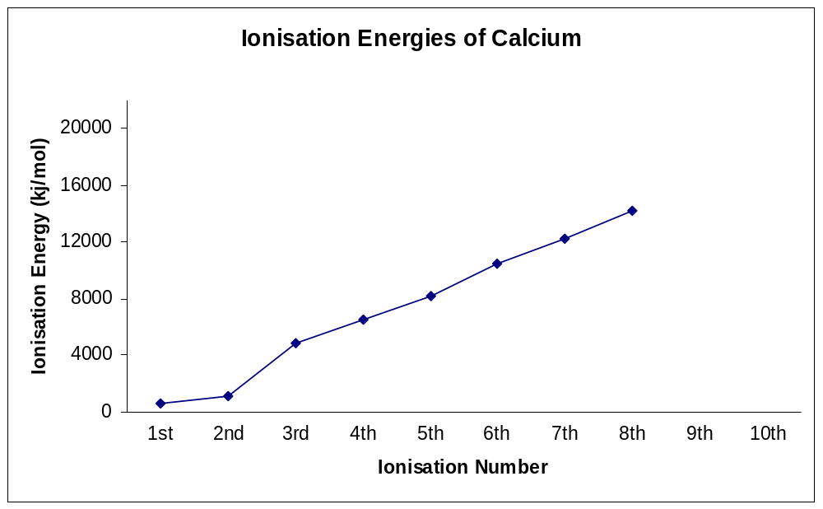

- Define ionisation energy. [1 mark]

- Explain the gentle increase between the first and second ionisation energies for calcium. [1 mark]

- Explain the significant increase in moving from the second to the third ionisation energy for calcium. [1 mark]

- Explain the gentle increase between the third and eighth ionisation energies for calcium. [1 mark]

- On the chart above indicate where you would expect the ninth and tenth ionisation energies for calcium would be. [1 mark]
- Explain your reason for this location. [1 mark]

- On the same axes above, sketch (and label) the graph you would anticipate for the first eight successive ionisation energies of magnesium. [1 mark]
- On the same axes above, sketch (and label) the graph you would anticipate for the first eight successive ionisation energies of strontium. [1 mark]
- Explain the position of the graphs for magnesium and strontium. [2 marks]

- List four different species that have the electron configuration of 2,8. [2 marks]

- Five elements and their electronic configurations are as follows:

Na: 2,1 Mg: 2,2 He: 2 O:2,6 S:2,8,6

- In a chemical reaction which element is most likely to: [3 marks]

    - Gain 2 e⁻?
    - Lose 2 e⁻?
    - Not react?
- Which element(s) form: [3 marks]

    - Covalent bonds?
    - Metallic bonds?
    - Forms a diatomic element?
- Which element: [2 marks]

          - Is the most reactive?
          - Has the smallest radius?

